Do you want to learn to play banjo?
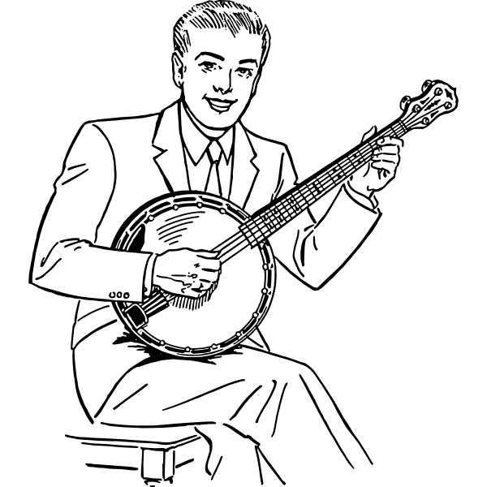

No thanks | No thanks | No thanks | No thanks | No thanks | No thanks | No thanks | No thanks | No thanks | No thanks | No thanks | No thanks | No thanks | No thanks

